CONTACT MANAGER API
Team Leader: JASMEEN BANU I S
Email id: jasmeenbanu2007@gmail.com
Team Member: GURUPRIYA U
Email id: priyaguru061@gmail.com

Team Member :HEMALATHA K
Email id: Shilpakannan83@gmail.com

Team Member: HEMAMALINI Y
Email id: hemayuva308@gmail.com

Team Member : HAMERA BEGUM G
Email id: hamerabegum0@gmail.com

1.Project Overview:
The ConnectHub Contact Manager API is a backend web application designed to solve the common problem of scattered contact information across multiple platforms. It provides users with a centralized, organized system to store, search, and categorize their professional and personal contacts. The application is built entirely as a backend service, exposing a set of well-defined REST API endpoints that can be consumed by any frontend client or tested directly using tools like Thunder Client or Postman.
- Key Objectives:
- Provide secure user authentication and complete data isolation between users.
- Enable efficient contact management through full CRUD (Create, Read, Update, Delete) operations.
- Implement flexible categorization using a tag-based system for contact organization.
- Offer fast search and filtering capabilities across contact name, email, and tags.
- Follow the MVC (Model-View-Controller) architectural pattern for clean, maintainable code.
- Target Users
- Freelancers and consultants managing client relationships and contact lists.
- Small business owners tracking vendor and customer contact information.
- Students and young professionals building their professional network.
- Event organizers managing attendee and volunteer information.
- Anyone seeking a simple, privacy-focused contact management solution.

2.Project Instructions:
This section provides a step-by-step guide to setting up and running the Contact Manager API on a local development environment.
Step 1:Install Node .js
Download and install Node.js from https://nodejs.org/. After installation, verify the setup by running the following commands in the terminal
node -v
npm -v
Step 2: Create a BackEnd Project Folder:
Choose or create a directory for the backend project. Open the terminal, navigate to the selected directory, and create the project folder:
mkdir server
cd server
Step 3 : Initialize the Node Project
Run the following command to initialize the project and generate a package.json file:
npm init -y
Step 4: Install Required Dependencies
Install the required npm packages for the project. Express is the core web framework, Mongoose is used for MongoDB integration, and nodemon enables automatic server restart during development
npm install express mongoose cors jsonwebtoken bcryptjs dotenv
npm install nodemon --save-dev
Step 5: Create the Basic Server File
Inside the server folder, create a file called server.js and add the Express server setup code with middleware configuration, basic routes, and port listener
Step 6: Enable ES Modules
Open package.json and add the following line to enable ES Module syntax (import/export) throughout the project
"type": "module"
Also add a dev script in the scripts section to use nodemon:
"dev": "nodemon server.js"
Step 7: Start the Backend Server
Start the development server using the following command :
npm run dev The console should display: Server running on http://localhost:5000
3.Pre-requisites :
- Software Requirements :
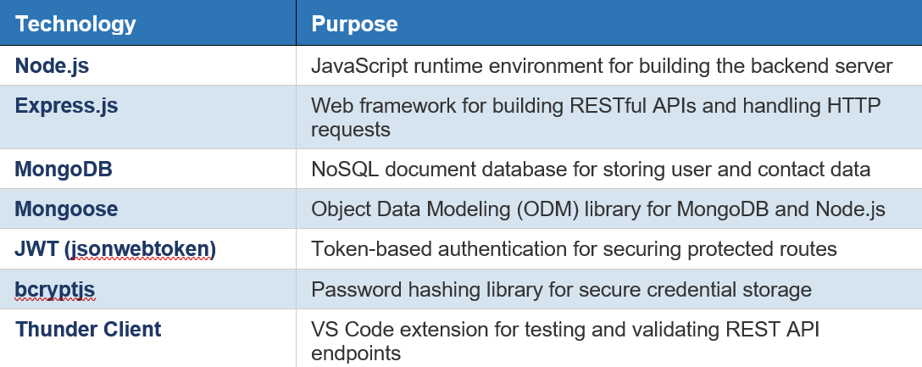

- Knowledge Requirements :
- JavaScript ES6+ syntax including arrow functions, destructuring, async/await, and modules.
- Node.js and Express.js for building RESTful APIs and handling HTTP methods.
- MongoDB and Mongoose ODM for schema definition and database operations.
- JWT authentication mechanisms and bcrypt password hashing concepts.
- Understanding of HTTP status codes and RESTful API design principles.
- Basic Git version control workflow for project management.

4.Project Architecture :
- Architecture overview
The system is built around an Express.js server that receives incoming HTTP requests and routes them through authentication and validation middleware before passing them to the appropriate controller. The controllers contain the core business logic and interact with MongoDB through Mongoose models. The following layers form the architecture:
- Express Server: The entry point that initializes middleware, routes, and the server listener.
- Middleware Layer: Handles JWT authentication verification and request validation before controllers are invoked.
- Controllers: Contain the business logic for user authentication (Auth Controller) and contact management (Contact Controller).
- Models: Define the Mongoose schemas and interact directly with the MongoDB database.
- Routes: Map HTTP endpoints to controller functions and apply appropriate middleware
.

- Node.js + Express Backend:
- RESTful API architecture with standard HTTP methods (GET, POST, PUT, DELETE).
- JWT authentication middleware for route protection.
- MVC pattern separating Models, Controllers, and Routes.

- MongoDB Database:
- Document-based NoSQL storage offering flexible schema design.
- Mongoose ODM for schema modeling, validation, and query building.
- Two collections: Users (authentication data) and Contacts (contact records).
- Indexed fields for optimized query performance.

5.TECHNICAL ARCHITECTURE:
- Backend Architecture (Node.js + Express):
- Controllers: Business logic handlers for authentication (register, login, get current user) and CRUD operations for contacts (create, read, update, delete, search).
- Models: Mongoose schemas defining the structure of User and Contact documents in MongoDB, including field types, validations, and relationships.
- Routes: API endpoint definitions that map HTTP methods and URL paths to controller functions, with middleware applied selectively.
- Middleware: JWT verification middleware (authentication.js) that protects routes requiring login, plus validation middleware for request body validation.
- Configuration: Database connection module (dbConfig/) and environment variables loaded via dotenv for sensitive configuration.
- Utility: Validation schemas using express-validator or custom validators to ensure data integrity on incoming requests.

- Database Architecture (MongoDB):
- Users Collection: Fields include _id (ObjectId), name (String), email (String, unique), password (String, hashed), and timestamps (createdAt, updatedAt).
- Contacts Collection: Fields include _id (ObjectId), userId (FK referencing User), name (String), email (String), phone (String), notes (String), tags ([String]), and timestamps.
- Relationships: Many-to-One relationship where each Contact belongs to exactly one User through the userId foreign key reference.
- Indexes: email field is indexed as unique in the Users collection; userId, name, and tags fields are indexed in the Contacts collection for efficient search queries
- Folder Structure :
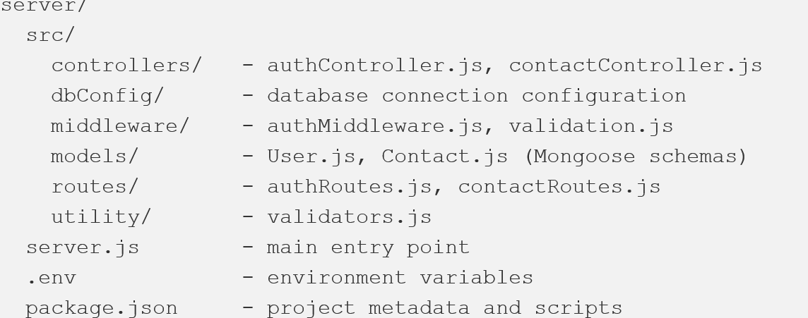

6.ER Diagram:
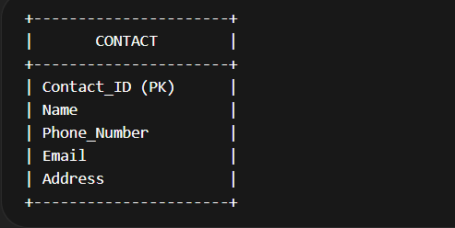
- System Architecture Diagram:
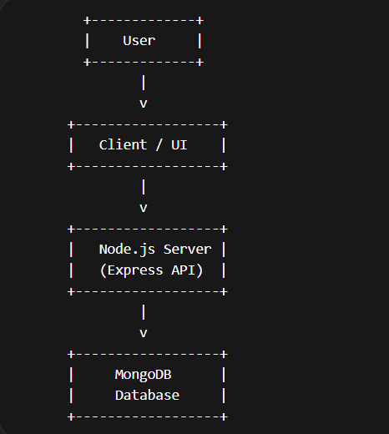

- User Flow Diagram:
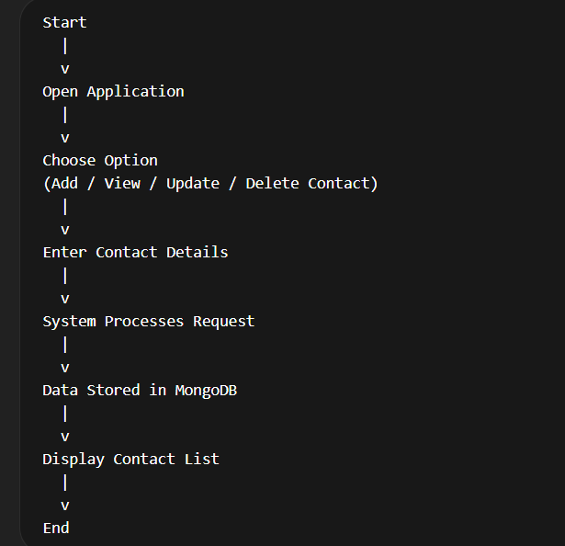

7.Features:
The main features of the Contact Manager System include:
- Add new contacts
- View contact list
- Update contact information
- Delete contacts
- Search contacts quickly
- Store contact data in database
- Easy and user-friendly interface

8.Roles and Responsibilities
- Project Developer
- Design the system architecture
- Develop backend APIs
- Create database schema and models
- Implement project features

- User:
- Add new contacts
- View stored contacts
- Update contact information
- Delete unwanted contacts

9.User Flow
The user flow explains how users interact with the system.
- User opens the application
- User chooses an option (Add / View / Update / Delete contact)
- User enters required contact information
- The system processes the request
- The data is stored or updated in the database
- The system displays the updated contact list
- Backend Development:
Backend development handles the server-side logic of the application.
In this project:
- Node.js is used to build the backend
- Express.js is used to create REST APIs
- APIs handle operations such as creating, retrieving, updating, and deleting contacts
- Backend ensures proper communication between the application and the database.
10.Database Development:
Database development focuses on storing and managing contact information.
In this project:
- MongoDB is used as the database
- Contact details are stored as documents
- Each document represents a contact record
- The database allows fast storage and retrieval of data.

11.Configure MongoDB:
MongoDB must be configured before using it in the project.
Steps include:
- Install MongoDB on the system
- Start the MongoDB service
- Create a database for the project
- Connect MongoDB with the Node.js application using Mongoose
- This configuration allows the system to store contact data.

12.Create Database Connection:
The database connection links the application with MongoDB.
Using Mongoose, the application connects to the database using a connection string. Once the connection is successful, the application can store and retrieve contact data from the database.
13.Create Schema and Models:
A Schema defines the structure of data stored in MongoDB.
Example fields in the Contact Schema:
- Name
- Phone Number
- Email
- Address
A Model is created based on the schema and is used to interact with the database for performing operations like creating and updating records.

14.Project Execution:
Project execution refers to running the application after development.
The application is executed using Node.js, which starts the server and allows users to interact with the system.
- Project Execution Steps:
- Steps to run the project:
- Install Node.js and MongoDB
- Open the project folder in VS Code
- Install required dependencies using npm install
- Configure MongoDB connection
- Run the application using node server.js or npm start
- Open the application in the browser or API tool
- Test features like adding and viewing contacts

15.Abstract:
The Contact Manager System is a software application designed to store and manage contact information digitally. It helps users organize contact details such as names, phone numbers, and email addresses in a structured way.
The system allows users to add, update, delete, and search contacts easily. It is developed using Node.js, Express.js, and MongoDB to demonstrate backend development and database management.
This project provides a simple and efficient solution for managing contacts and helps improve knowledge in web development, API creation, and database integration.

16.Output Screenshots:
- Register Api:
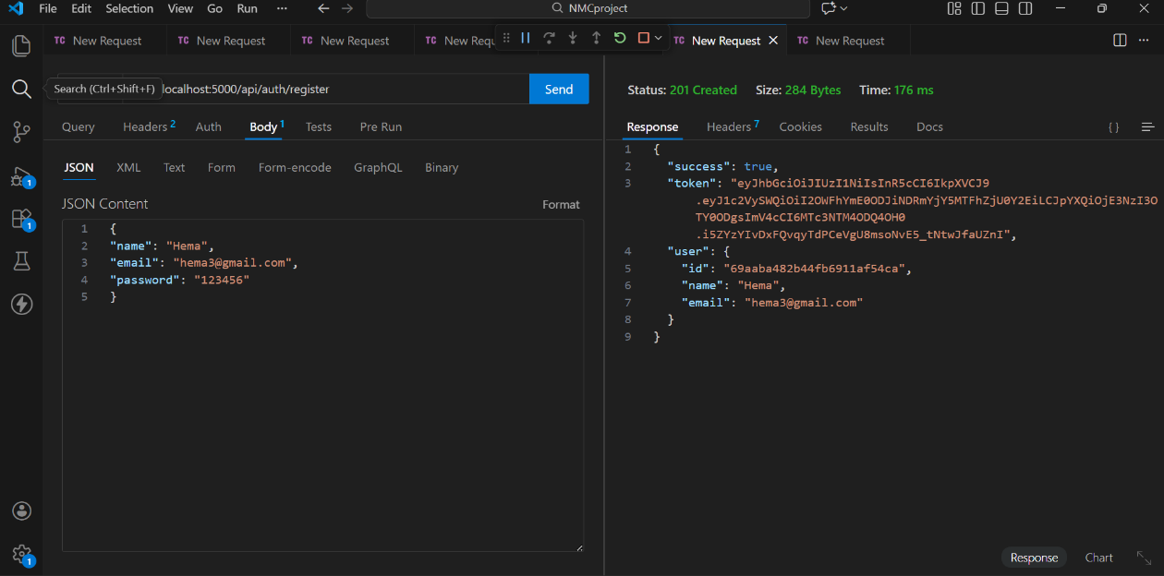

- Login Api:
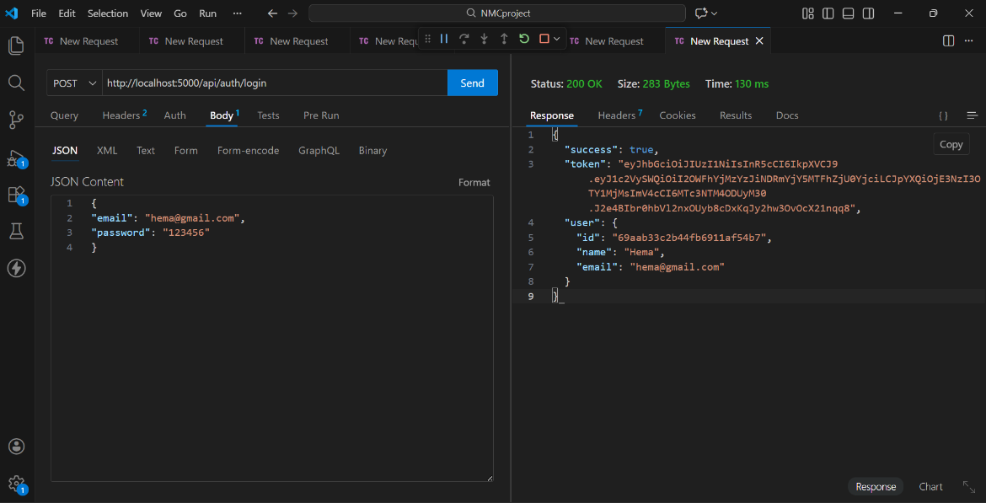

- Create New Contact:
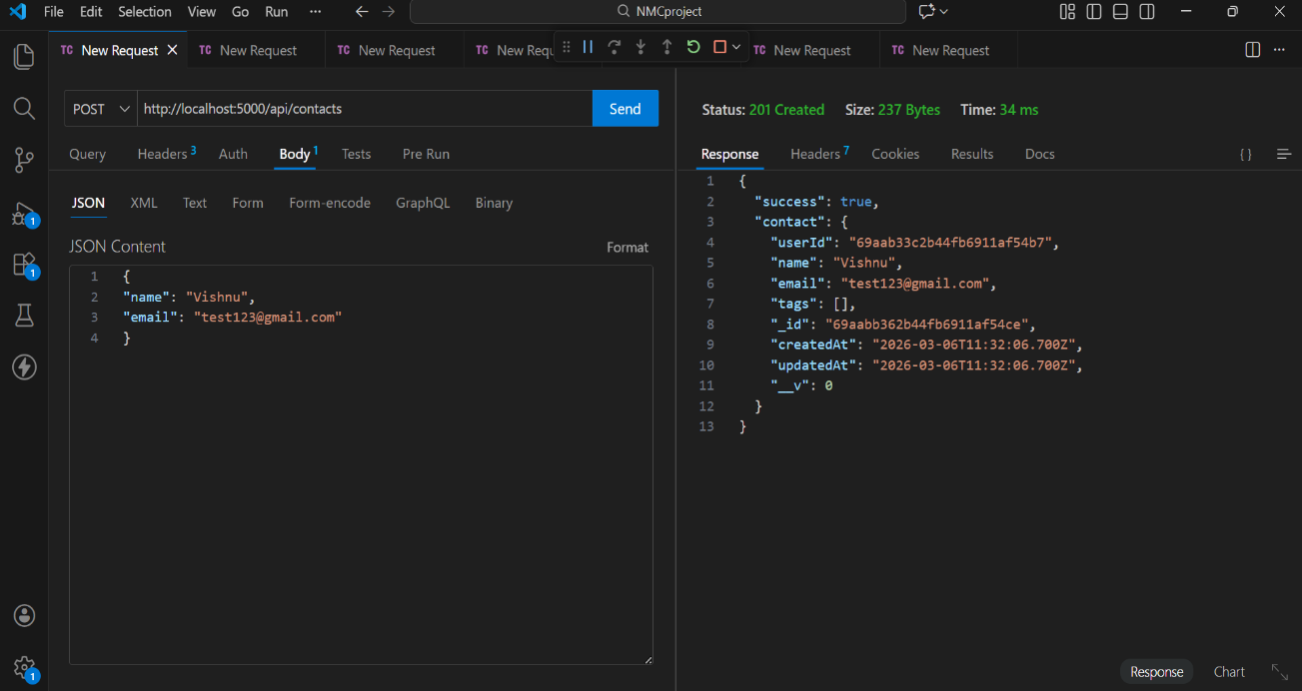

- Update Contact:
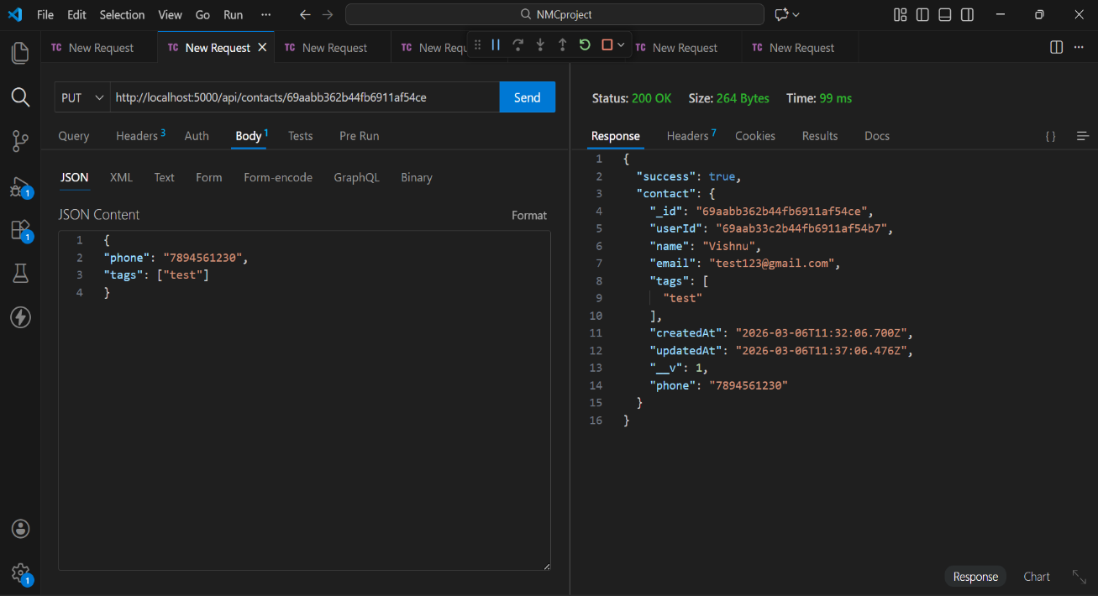

- Delete Contact:
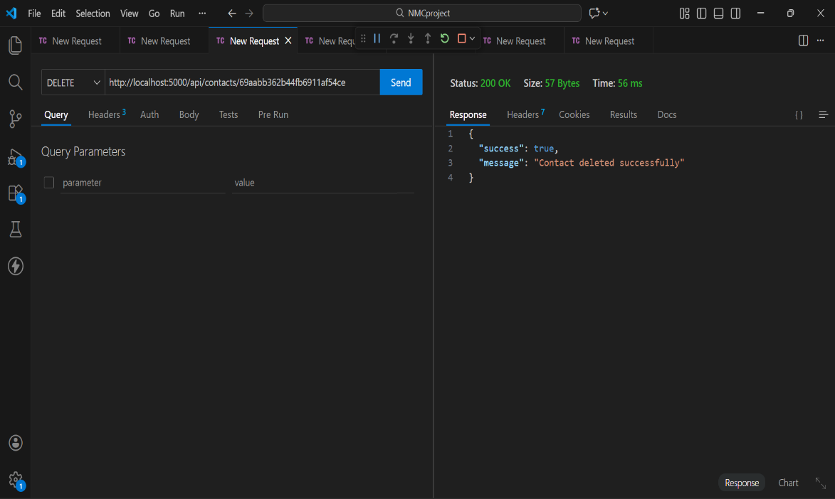

- Search Contact:
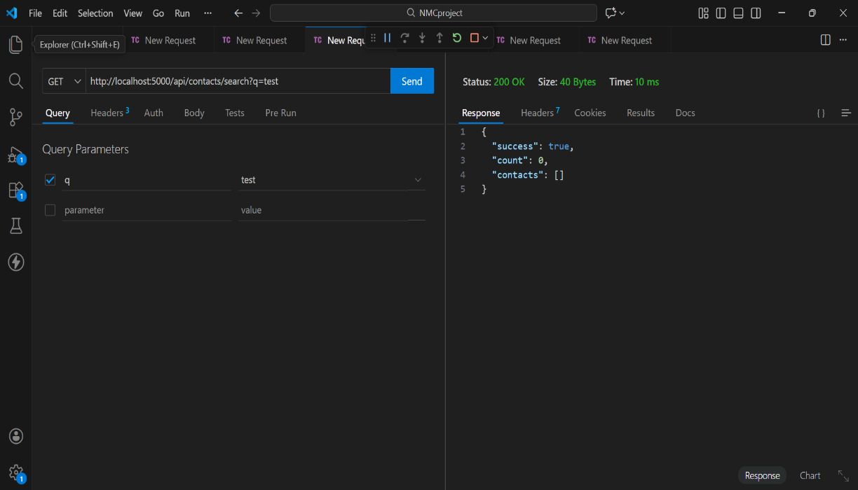

- Get The Current User:
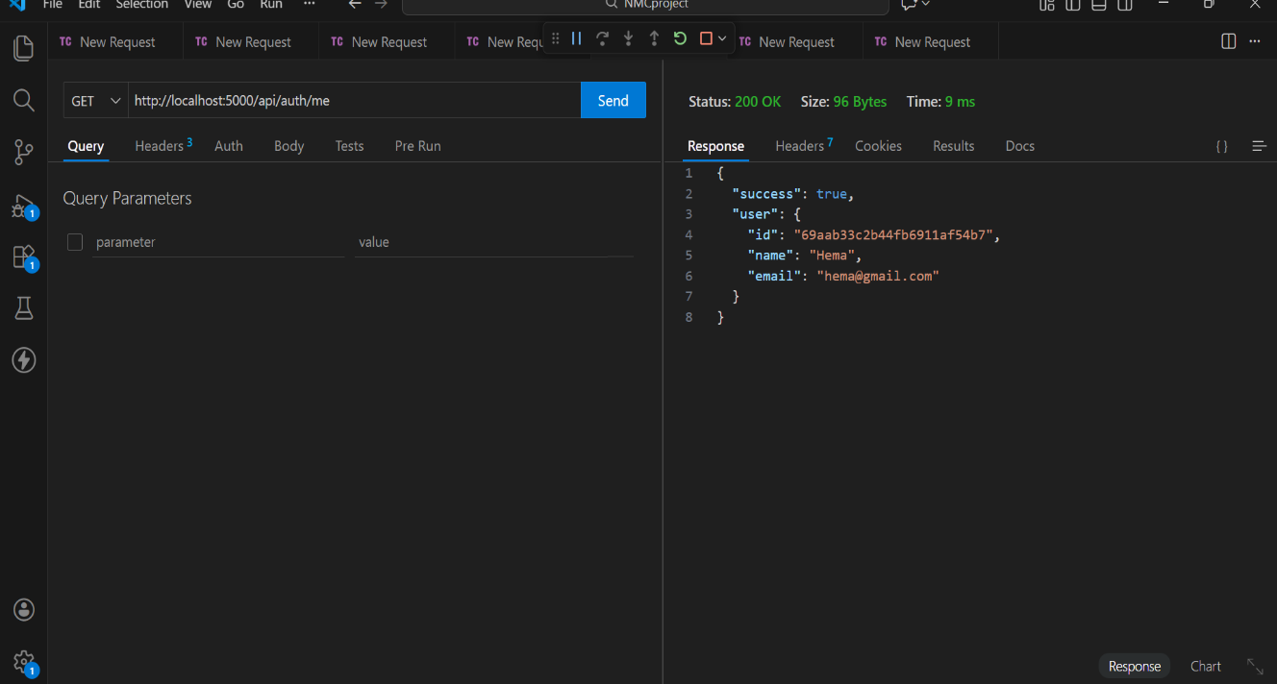

Project Demo: Contact Manager.webm

Code Link:NMCproject\server

